**Real-time Stabilization and 3D Reconstruction of Hand Gestures and Finger Movement Traces Using LED-Equipped Gloves**



***Use Case Summary Document***

**Version No. 1.0**

**Project Document Revision History**

| **VersionNumber** | **Date** | **Revision Author** | **Description of Revision** |
| --- | --- | --- | --- |
| 1 | 10/08/2024 | Zaynab Mourtada | Original |
|  |  |  |  |

| **Table of Contents** |
| --- |

**1. Introduction 3**

**2. Project/Application Actors 4**

**3. Use Case List 4**

**4. Use Case Diagram(s) 5**

**5. Use Case Summary 5**

**6. Use Case Summary Review and Signoff 6**

# **Introduction**

The purpose of this project is to develop an innovative mobile application that captures, stabilizes, and smooths virtual writing and finger movements in real-time using LED-equipped gloves and a rolling shutter camera. This application leverages advanced image processing techniques and machine learning algorithms to refine the captured gestures, offering accurate recognition and seamless user interaction. By reconstructing the hand’s 3D movements, the system will enable real-time gesture tracking and enhance user experiences across different platforms, including virtual reality (VR) and augmented reality (AR) environments. Additionally, the project will integrate these movements into interactive systems such as video games and smart home devices, transforming hand movements into intuitive control mechanisms.

The project is divided into key modules, each of which serves a critical function in achieving the application's overall goals. The Mobile Application allows users to initiate and stop gesture tracking while managing the setup of the camera and LED gloves. The VR/AR module allows users to visualize their handwriting by displaying the smoothed and tracked movements of their LED-equipped hands. The Image Processing module is responsible for capturing and enhancing hand gestures through pre-processing techniques, generating precise movement data for further analysis. The Machine Learning module refines the data using Kalman filters and RNN models to ensure smooth and accurate tracking, even in challenging conditions. Lastly, the 3D Visualization module translates the captured hand poses into commands for video games or smart home devices, allowing users to control external systems through natural hand movements.

This document captures the high-level business requirements by outlining all the use cases for each module within the project. The successful implementation of this application will offer users an intuitive and responsive system for real-time hand gesture tracking and recognition, with wide-ranging applications in VR/AR environments and smart home technologies. The integration of advanced machine learning and image processing ensures the system is both robust and scalable, providing accurate gesture recognition even in complex or noisy environments.

# **Project/Application Actors**

An actor is someone or something (e.g. application system) outside the system or business that interacts with the application. List the actors involved in ANY use case. Actors should be a person, system, or time.

| Actor Name | Description |
| --- | --- |
| **User** | **The end-user who interacts with the application.** |
| **System** | **The entity that processes inputs and returns the outputs to the user.** |

# **Use Case List**

3.1 Mobile Application

3.2 VR/AR

3.3 Image Processing

3.4 Machine Learning

3.5 3D Visualization - Hand Pose Commands for Video Games/Smart Homes

# **Use Case Diagram(s)**

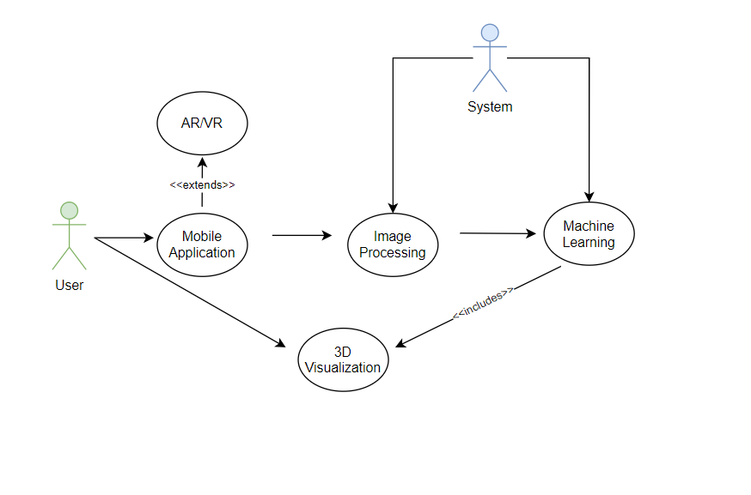

# **Use Case Summary**

5.1 **Mobile Application:**

The mobile application we are developing will allow the user to start and stop finger tracking. Additionally, users will be able to set up both the camera and LED gloves. However, there may be exceptions that cause errors during each function. When interacting with the gloves and camera, the user might encounter errors triggered by one of these exceptions. Since the processing of LED glove and camera actions occurs on the server side, users may also face server-related exceptions. The setup processes for the camera and LED gloves may result in specific device-related errors.

5.2 **VR/AR:**

When the project is implemented on the AR/VR platform, users will be able to view the 3D rendering of the user’s finger movements generated by the software, along with monitoring tremors in the hands and fingers by collecting real-time hardware and calibration data. Users will have the ability to optimize both the camera and LED gloves for seamless integration with the AR/VR interface. However, potential backend exceptions may arise, triggered either by hardware malfunctions or server issues. These hardware and server exceptions are consistent with those encountered in the mobile use case.

5.3 **Image Processing:**

This use case outlines the functionality of the Image Processing Module for real-time finger movement tracking, allowing users to interact with the system via a simple interface to start and stop tracking hand movements captured by a camera. The module processes visual data, extracting key features to recognize gestures and provide real-time feedback. The process begins when the user clicks the "Record Gestures" button, triggering the camera to capture frames in real time using the Camera2 API. These frames undergo pre-processing steps within the Image Processing Module, such as sharpening, denoising, edge detection, and thresholding, to enhance the image quality. Following this, key features like the 2D coordinates, depth, and timestamp are extracted using OpenCV. This data is then compiled into a 4D data structure (X, Y, Z, T), representing the LED's path in 3D space. Advanced filtering techniques, including Kalman Filters and spline interpolation, smooth the gesture path for accuracy. The final smoothed data is output as a 4D NumPy array, ready for further analysis by the Machine Learning Module. The system handles exceptions such as camera malfunctions or processing errors, ensuring robust gesture recognition and enhanced user interaction.

5.4 **Machine Learning:**

This use case describes a machine learning module for adaptive HCI, designed to smooth virtual writing trajectories in real-time. The system reduces noise and standardizes input data, extracting key features for processing. A hybrid neural network model refines the data, capturing both spatial and temporal aspects. Optimized for mobile and AR/VR, the module delivers a smooth and accurate 3D trajectory, enabling responsive and precise user interaction.

5.5 **3D Modeling - 3D Finger Tracking for Air Writing Recognition:**

This use case describes how a 3D modeling application can be used for adaptive Human-Computer Interaction (HCI) techniques. The application recognizes finger movements in front of a camera to interpret writing. The application tracks the user's finger movements, reconstructs them in real-time, and interprets the resulting paths as characters or symbols. These characters can serve as input for various applications.

# **Use Case Summary Review and Signoff**

| Review and Signoff of the Use Case Summary | | | | |
| --- | --- | --- | --- | --- |
| Name | Project Team Role | Signature | Date | |
| [Xiao Zhang](mailto:zhanxiao@umich.edu) | Client |  | 10/09/2024 | |
| [Deniz Acikbas](mailto:dacikbas@umich.edu) | Lead Mobile and AR/VR Developer | [Deniz Acikbas](mailto:dacikbas@umich.edu) | 10/08/2024 | |
| [Soham Naik](mailto:umeshnaik13@gmail.com) | Lead Image Processing Engineer | [Soham Naik](mailto:umeshnaik13@gmail.com) | 10/08/2024 | |
| [Alan Raj](mailto:alanraj@umich.edu) | Lead 3D Simulation Engineer | [Alan Raj](mailto:alanags754@gmail.com) | 10/08/2024 | |
| [Zaynab Mourtada](mailto:zaynabmo@umich.edu) | Lead Machine Learning Engineer | [Zaynab Mourtada](mailto:zaynabmo@umich.edu) | 10/08/2024 | |